

Appointment of Pro Vice-Chancellor or CIO-Executive Director
of the
Division of Knowledge Management

Information Booklet for Candidates

Contents Page

Vice-Chancellor’s overview 3

Advertisement 5

University of Canberra Academic Structure 7

Head of the Division of Knowledge Management 7

Role – Head of Knowledge Management 10

Selection criteria 13

The University of Canberra 14

University Organisational Structure 16

University Strategic Plan 17

Remuneration and How to Apply 19

Websites of interest and further information 20
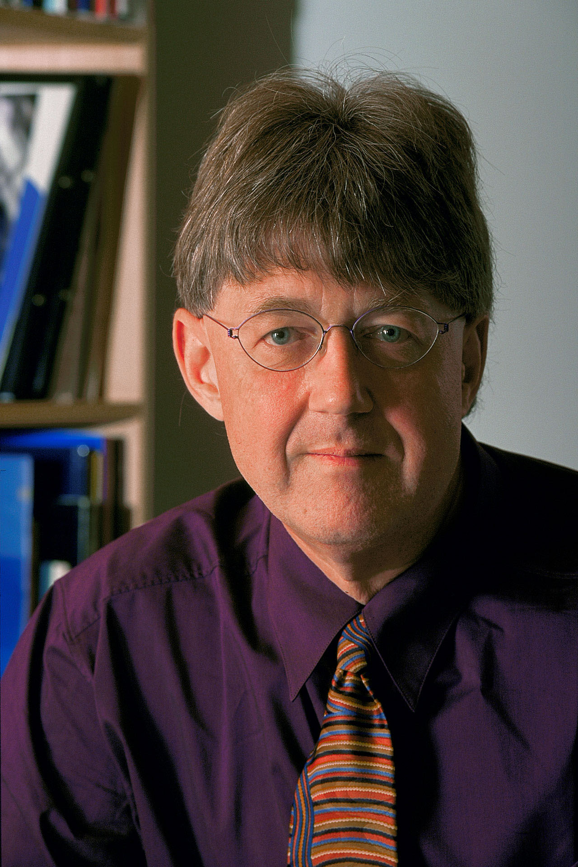

Message from the Vice-Chancellor

The University of Canberra is a high quality, small University, which consistently scores above its weight, and aims to do so even more, in research, teaching and learning, internationalisation, and regionalism. It is an unusually friendly University, partly because of its size. But this feature is one we seek to enhance and exploit. We are already clearly the leader among New Generation Universities in research, and indeed we score much more highly than that would imply in terms of research income per academic staff full-time equivalent (fte). We also came No. 8 in the 2006 table of Universities in relation to teaching and learning performance, a position we are proud of, and which we are confident of deserving. Our Australian Universities Quality Assurance Agency (AUQA) report would support this.

We seek a Pro Vice-Chancellor (PVC) or Chief Information Officer (CIO)-Executive Director who will be accountable for planning, leading and directing the University’s knowledge management systems to provide staff and students with access to contemporary and cost effective information communication technology and knowledge delivery. PVC is our terminology for someone with a highly developed academic background; ED for those with more of a corporate professional background.

The PVC/CIO-ED will operate within the Vice-Chancellor’s Advisory Committee (VCAC) as a confident and contributory peer. The most important aspect of the role is the strategic, in relation to Divisional roles, and the management of knowledge transfer to the University community and external. I imagine that very strong candidates might emerge both from a primarily academic/higher education environment, and from a information communication technology/knowledge management oriented environment within commercial or public sectors. With this in mind I have pointed at certain flexibilities within the portfolio (such as the University Library) which might be adjusted to suit leading candidates.

The Vice-Chancellor's Advisory Committee is a highly productive and interactive group, with strong cohesion and solidarity. It is rare that any decision is other than highly consensual.

I hope you find the concept of this new and innovative appointment of Pro Vice-Chancellor/CIO-Executive Director and Head of the Division of Knowledge Management an appealing one. This appointment will be finalised by my successor Professor Stephen Parker, who will become Vice-Chancellor on 1 March 2007.

Roger Dean



Professor Roger Dean, FAHA,
Vice-Chancellor and President.

Advertisement


- KNOWLEDGE MANAGEMENT OPPORTUNITY
- NEW AND INNOVATIVE APPOINTMENT
- STRATEGIC SENIOR EXECUTIVE ROLE
PRO VICE-CHANCELLOR or CIO EXECUTIVE DIRECTOR KNOWLEDGE MANAGEMENT University of Canberra
The Vice-Chancellor wishes to appoint a Pro Vice-Chancellor or CIO-Executive Director as the Head of the Division of Knowledge Management.
The University of Canberra is taking the opportunity to create a new position which reﬂects the changing university environment of the 21st century. Knowledge management is one of the key tools which will contribute to the balance of the four core areas: enterprise, research, education and communities. This position will generate and apply knowledge management across all aspects of the University’s activities to support present and future needs of the region, nation and global community.
Reporting to the Vice-Chancellor, the successful candidate will lead the development, design, delivery, support and integration of the University’s knowledge management systems and associated ICT platforms, applications and infrastructure to ensure the highest standards of quality and data integrity.
Applications are sought from candidates demonstrating exemplary senior management skills, high academic qualiﬁcations and/or a recognised professional reputation in establishing and leading information technology services in a large organisation. The appointee will be the University’s Chief Information Ofﬁ cer.
The person must have excellent people skills and be responsible for establishing and/or maintaining a communicative and client-responsive culture. The person will need to have ﬁnancial and negotiation expertise and the capacity to operate productively with a wide range of stakeholders.
The Division of Knowledge Management comprises the speciﬁc areas of information communication technology, and knowledge management more broadly e.g. the University Library. The person will be responsible for the growth, coordination and integration of these areas and for promoting a sense of unity, cooperation and common purpose in their relationships across the University.
Candidates should have an excellent track record of leadership with an established academic and/or professional background. Academic and professional applicants are equally sought.

The Application Process
For a confidential discussion and in order to receive an Information Booklet, which contains the Selection Criteria for the position, please contact the Consultants assisting the University in this Executive Search:

Higher Education sector enquiries Corporate or Government sector enquiries
Dr Jim Sait Andrea Galloway
BSP Executive Search BSP Executive Search

02 8904 1532 02 9956 8242
jim@bspes.com andrea@bspes.com

The closing date is Monday 8th January 2007

The University retains the right not to make an appointment.

The anticipated timeline for the process of the appointment of PVC is as follows:

PVC/CIO-ED Advertisement November 21, (IT pages The Australian)
PVC/CIO-ED Advertisement November 22 (HE pages The Australian)
PVC/CIO-ED Advertisement November 24 (The Financial review)
PVC/CIO-ED Advertisement November 25 and 26th(Weekend Australian)
PVC/CIO-ED Advertisement November 25 (The Canberra Times)

Closing date Monday 8th January 2007

Short listing The week of the 16th February

Interviews 8th March 2007

The University of Canberra

The University focuses on educating professionals and undertaking applied, relevant, research. Its key obligations are to the ACT and Australian Capital Region (320,000 people in our surrounding NSW area).

The University’s three academic teaching and research Divisions are:

- Business, Law and Information Sciences
- Communication and Education
- Health, Design and Science.

The University’s four academic support Divisions are presently:

- Learning and Teaching
- Resources
- Development and International
- Research and Information Management

We now plan to remove Research into a pre-existing VCAC portfolio and create a new Division of Knowledge Management.

In pursuance of its commitment to the education of professionals, the University of Canberra has established a strong record of achievement in applied and professional research and consultancy work that contributes directly to the knowledge base of professional practice and quality of life.

The Head of the Division of Knowledge Management

The appointee will lead the development, design, delivery and support of the integrity and integration of the University knowledge management systems and associated Information Communication Technology (ICT) platforms, applications and infrastructure.

He/she will participate in the strategic identification of growth opportunities and oversee the University’s knowledge management systems in particular:

- The identification of explicit and tacit knowledge,

- The codification, preservation and dissemination of knowledge including reporting requirements,

- The management of knowledge transfer and educational development to the University community and society,

- The development and implementation of business plans and approved budgets in accordance with the University’s overall corporate strategies and direction, and

- The fostering of collaboration between the user/client and key stakeholders in meeting the University of Canberra needs.

The Knowledge Management System Description

The Knowledge Management System will be the virtual centre for:

- The systematic recording and storing of University - related information and expertise,
- The ‘packaging’ of organisational and corporate expertise, University information (educational and research), knowledge and learning for use by a variety of clients,
- Maximising the usability and usefulness of the University Library, resources and information products for different user groups,
- Promoting the meaning and purpose of information and knowledge resources and products to internal and external constituencies, and
- Ensuring the ready access and easy retrieval of information/knowledge resources.

The Knowledge Management System encompasses Information Management and ICT platforms, applications, services and infrastructure. It is also expected to encompass the University Library, but some flexibility about how this is managed will exist for candidates with less experience in the higher education sector.

The University Information and Technology Services

The Information Communication and Technology Services enables and supports teaching, learning, research and administration by providing, managing and integrating services in information management and information technology. The Services provided include:
- UC Online and Web Systems Program which covers the University’s web site and the University’s digital repository and e-publishing initiatives.
- The Servers and SOE (standard operating environment) Program that is responsible for the development, implementation and management of the University’s SOE installation and maintenance.
- Communications and Technical Support Programs that plan implement and enhance the University’s data network, audio-visual technology and telephone switchboard services.
- Enterprise Systems Support Programs that provide University wide support for the implementation and management of ICT systems.
- Service Desk Programs that cover the operations of a Campus wide service desk and desktop support to ensure appropriate first or second level support is available to all users within acceptable timeframes.

Information, Communication and Technology Services support a diverse range of information technologies that ensure a flexible environment that is responsive to the various needs of teaching, learning and research. The University is moving towards increased integration of ICT services, systems and an electronic information environment, with many services delivered over the network using browser based client-server technology.

University of Canberra Library

The appointee will monitor the policies, programs and services of the University of Canberra Library to provide efficient and effective services while using sound judgement within an environment that emphasises high quality library and information services to staff and students. If the appointee has a strong academic background, he/she will also provide vision and strategic planning for the Library’s technology infrastructure and digital initiatives; if the appointee is stronger in Corporate knowledge management, the Library relationship will be in a matrix management structure also involving the Pro Vice-Chancellor Academic.

Specific duties may include, but not necessarily be limited to the following;

- To develop high-level strategies that contribute to the coordination and interpretation of library-wide services that support teaching, learning and research;
- To provide strategic planning for the design, integration, and maintenance of the library-computing environment and for specification, acquisition development;
- To provide leadership and support of digital library collections, tools, services and support applications that facilitate teaching, learning and research.

Staffing Profile –

- Information Communication and Technology Services – continuing and contract staff – 66 FTE

- University Library – continuing and contract staff - 48.6 FTE
The Role

The Pro Vice-Chancellor or CIO/Executive Director of the Division of Knowledge Management will be a member of the University’s top-level management team (Vice-Chancellor’s Advisory Committee). He/she will provide assistance to the Vice- Chancellor and will contribute significantly to planning, strategy and achievement of the operational goals of a knowledge-focused University. Additionally the person will be responsible for managing a specific Divisional unit.

The person will:

- Provide strategic leadership in the area of knowledge management as a technique for the management of the intellectual assets of the university,
- Oversee the development of knowledge and information as a core business function for all stakeholders,
- Provide the ‘hands-on’ expertise required to manage organisational expertise in the form of knowledge and information library, resources and products,
- Support the University through educating stakeholders in understanding business needs and translating them into knowledge systems and solutions,
- Lead development and oversight of the University of Canberra Library.
- Lead development and oversight of Information Communication and Technology Services (ICT).

Senior Executive (Vice-Chancellor’s Advisory Committee)

The appointee is to contribute to the effective management of the University by participating with other members of the Vice-Chancellor’s Advisory Committee in planning and decision-making and by providing specialist advice and support.

The following comprises the University’s present senior executive

- Deputy Vice-Chancellor Professor Sharon Bell
- PVC Communication and Education (Professor Carole Kayrooz to take up the appointment on 1 March 2007; currently Professor Peter Putnis, whose term expires at the end of 2006)
- PVC Business, Law and Information Sciences (Professor Deborah Ralston)
- PVC Health, Design & Science (Professor Sue Thomas)
- PVC Academic – Teaching Learning and Research (Professor John Dearn)
- PVC Research and Information Management (Professor Andrew Cheetham
- Executive Director Resources – Chief Finance Officer (Mr Garry Foran)
- Executive Director Development & International (Ms Jandy Godfrey)

Personal Qualities (Qualifications, Experience, Competencies)

- Postgraduate qualifications preferably in a relevant field e.g. Information Services, Knowledge Management, Library Sciences,
- Demonstrated leadership and planning capabilities,
- Superior communication and relationship-building skills,
- Aptitude to embrace both the academic and corporate enterprises,
- In-depth understanding and appreciation of the capabilities and limitations of information technology,
- Ability to lead the management of knowledge and information via online databases, collaborative technologies and web-based services,
- Understanding of the principles and processes of knowledge management as a management tool and technique to enable organisational learning and development in the knowledge economy,
- Substantial experience across a broad range of platforms (systems and services) for diverse management needs,
- Project management skills, preferably in the education sector to ensure the delivery of outcomes in a timely and efficient manner,
- Success in the delivery of cultural transformation including the reviewing of the impact of individual and institutional changes. He/she will need to negotiate links between previously discrete areas of the University’s activities.

  - If from a corporate background able to embrace the academic enterprise, if from an academic background fully versed in the requirements of a corporate and technology-driven role.
  - A key target of the appointee will be to encourage a communicative and client-responsive culture in the ICT team, complementing that in place in the University Library.

- Ability to provide solutions for broad knowledge based application systems related problems, and
- Expert knowledge in adhering to industry best practices and procedures in regards to security, reliability, and scalability.

Key Performance Indicators (Measurement)

- Develop, implement and achieve a quality innovative knowledge management system for the university,
- Contribute to the development and achievement of strategic and operational plans for the University,
- Develop the resourcing and budgetary strategies to ensure a timely and cost effective delivery of quality services, including the selection and retention of professional staff,
- Ensure that utilisation of funds is consistent with strategic objectives,
- Provide coherent advice to the Senior Executive Team on educational information, knowledge management systems and corporate services,
- Establish a Virtual Centre for the knowledge and information resources/products of the organization,
- Actively support all aspects of the University’s operations including: teaching and learning; research, student administration, corporate business systems, and publicly available on line materials

- Oversee and maintain the University library, ICT services including Internet and Intranet sites,
- Ensure that all operations meet best practice quality requirements,
- Lead the staff professional development in information literacy and knowledge awareness i.e. in systematically identifying, collecting, reviewing, sharing and retaining high-value knowledge,
- Ensure compliance with relevant legislation e.g. copyright and intellectual property, financial regulatory requirements and government statistical reporting,
- Explore opportunities for advancing the position of the University through thought leadership and partnership, and
- Establish and maintain links with relevant internal and external stakeholders.

Selection Criteria

In determining experience relative to qualifications, regard will be given to demonstrated academic/scholarly/professional leadership in a university in his/her discipline with respect to accountabilities of knowledge management in relation to all information and communication technology and related services.

Experience beyond tertiary education and professional contributions will be well regarded.

- Qualifications and Background

(i) Academic applicants – Advanced academic qualifications normally at Doctoral level and recognised significant experience and publications record, normally at Professorial level.
(ii) Professional/general applicants – tertiary qualifications and senior executive experience in business or other related fields, accreditation and standing and extensive experience in planning and directing information technology and related services.

2. Proven ability to develop, implement and evaluate strategies to achieve the mission and goals of the Division/University.

3. Outstanding record of leadership, planning and implementation capability including demonstrated leadership in respect of staff and resource management, staff mentoring, research, community interaction and professional/academic excellence.

4. Substantial senior experience in developing and implementing innovative policies and practices to achieve outcomes.

5. Demonstrated effective interpersonal, negotiation and communication skills, and the capacity to engender trust and commitment in a client-responsive environment.

6. Demonstrated financial and resource management skills.

7. Demonstrated capacity to foster an entrepreneurial:
(i) teaching and research culture in the areas related to the established strengths of the Division.
(ii) range of activities of benefit to the Division and the University together with demonstrated links with outside organisations.

8. Sound knowledge of the higher education sector at a senior executive level.

9. Demonstrated understanding of, and commitment to implementation of health and safety and equity principles.

The University of Canberra

The University of Canberra

The University of Canberra is in the suburb of Bruce in the Australian Capital Territory, adjacent to the Belconnen Town Centre and about eight kilometres from the central business district of Canberra. The Bruce precinct includes a technology park, the Australian Institute of Sport, a campus of the Canberra Institute of Technology and several government departments.

Undergraduate and postgraduate courses are offered by ten Schools organised within the University’s three Academic Teaching and Learning Divisions: Busines, Law and Information Sciences, Communication and Education and Health, Design and Science. The University of Canberra has one of the highest employment rates for graduates in Australia (five star rating) and in 2006 was ranked eighth among the thirty-eight Australian universities for its learning and teaching performance.

We currently have around 10000 students with around 25 per cent enrolled in postgraduate studies and 19% international students from 80 countries. The University provides a full range of professional education services to meet the training and development needs of organizations such as professional bodies and government departments and uses flexible formats such as intensive teaching, web-based courses and distance education.

The University of Canberra is the University for the ACT and the Australian Capital Region, in terms of attracting and serving students, and the first partner for applied research towards economic, environmental or social-cultural development. We carry out research, training and development for the advancement of the professions making it applied and relevant to what we teach, and to the activities and industries of our region.
The reputation of the University’s researchers and our major research areas extends internationally. Our leading University Research Centres are in Applied Ecology and Socio-Economic Modelling. Other developing research groups are - communication, education and innovation, tourism, government and health. The University of Canberra is also closely involved with three Commonwealth Cooperative Research Centres (CRCs) : eWater, Australian Invasive Animals, and Sustainable Tourism. The University is the leading research university amongst the New Generation Universities (NGU), and generally reaches twenty-one in the overall tables, in spite of having only become a University in 1990. It aims to enhance this position further.

University Governance and Organisational Structure

The University of Canberra was established by the Commonwealth Government in 1967 as the Canberra College of Advanced Education. The University of Canberra Act came into effect on 1 January 1990 replacing the earlier 1967 Act. On 1 December 1997 jurisdiction for the University was passed to the Australian Capital Territory.

The governing body of the University is the Council as set out in the University of Canberra Act 1990. Council creates the basis for management excellence by developing the University’s mission statement and setting the strategic direction, as well as approving the annual budget and business plan. Council also ensures accountability of all University systems and this includes overseeing and monitoring the University’s academic activities through its Academic Board.

In 2005, following a review of the operational activities and organisational structure of the University, Council agreed to appoint a Deputy Vice-Chancellor. Professor Sharon Bell took up the position of Deputy Vice-Chancellor in May 2006. More recently, with the creation of the Division of Knowledge Management, all aspects of knowledge management in the University will be brought together in one distinct area headed by the position of Pro Vice-Chancellor/Executive Director, Division of Knowledge Management.

The present 2006 University of Canberra Organisational Structure is shown on page 16.

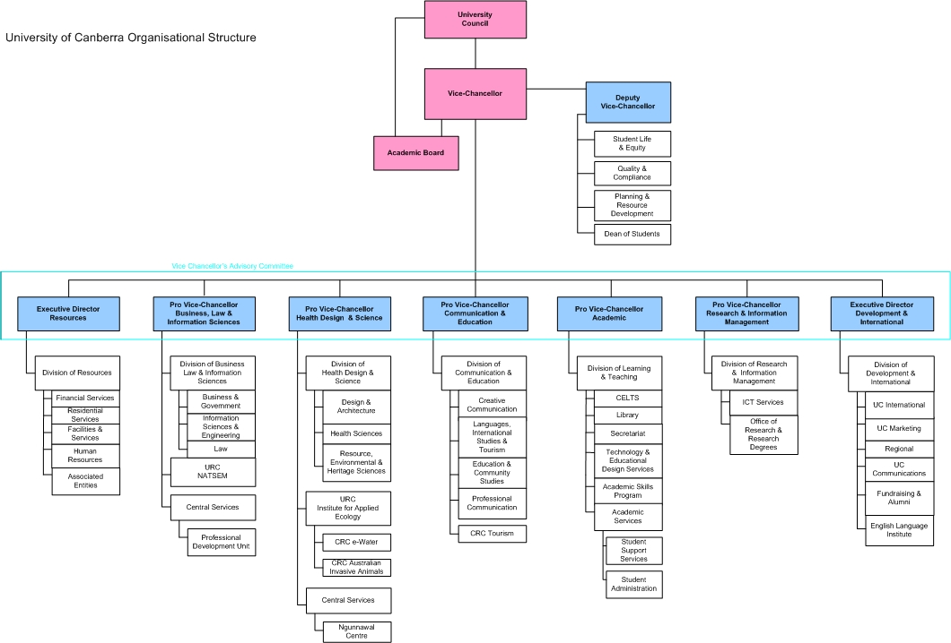
University of Canberra Strategic Plan

University of Canberra Strategic Plan 2003-2006

Over the past six months extensive discussions have taken place in preparation for the new University of Canberra Strategic Plan 2007-2010. Discussions with large groups of staff have been held in all Divisions and several Vice-Chancellor’s Forum addressees have specifically focused on the Strategic Plan. It is expected that the University Council will sign off on the new Strategic Plan in late 2006 or early 2007.

1. Strategic Plan
Vision

UC aims to be a leading Australian university for students, professionals and academics who integrate enterprise, innovation and creativity with teaching, learning and research, and focus on the needs of the global, national and regional communities.

Mission

We seek to develop an internationally oriented and respected University which educates and serves expert, creative and socially useful professionals, through diverse and flexible learning processes.
• In our teaching and learning we aim to instill in our students and staff the competence, knowledge, flair, adaptability, team skills and desire to achieve benefits for themselves and society, in part through lifelong learning and ethical reflection.
• In our research, enterprise and community service, we aim to generate and apply knowledge which will serve present and future needs of our region, nation and the global community.
• Overall, we aim to bring a balance to our four core areas of education, research, enterprise and community service, and to the contribution they can make to the regional, national and international communities we serve.

Values and Functions
The following are paraphrased from the University of Canberra Act (ACT, 1989, and as revised subsequently) with minor additions:

Our values involve commitment in an international context to:
a. service to scholarship and the education of Australians
b. responsiveness to the needs of Australia
c. fairness and integrity
d. efficiency and effectiveness
e. accountability for the exercise of the university’s functions.

The functions of the university include:
a. to create and communicate knowledge by means of teaching and research of the highest quality
b. to encourage undergraduate and postgraduate study and research
c. to provide facilities and courses for Australian and international students for higher education generally, and particularly for professional occupations
d. to award degrees, diplomas and certificates, whether in its own right, jointly with other institutions, or as otherwise determined by the council; always partnering with organizations of high quality, and with the potential to make significant contributions to their communities.
e. to foster lifelong learning in graduates and others alike
f. to pursue community activities which benefit society at large. In the exercise of its functions, the university pays special attention to the needs of the ACT and the surrounding Australian Capital Region.
2. STRATEGIC OBJECTIVES
In a framework of enhancing UC’s profile, and maintaining and diversifying resources and facilities, the following are priorities for the next 3 years of the development of UC :

A. In Education
Undergraduate education:
- to provide professional education which balances the theoretical, the practical and the creative
- to use inquiry-based and technology enhanced flexible learning environments to support students.

Postgraduate education:
- to provide education which enhances the professions and the professionals

Partnerships, Regional and International:
- to enlarge the cooperative capacities of all our students and staff, through teaching and research collaboration
- to be an employer of choice for University staff

B. In Research and Enterprise
Research:
- to enhance UC’s output, while maintaining a particular focus on the utility and social benefit of the research

Commercialisation:
- to more fully harness the commercial potential of our research, teaching and administrative knowledge, as an aspect of broadening our funding sources

Application:
- to more fully harness our non-commercial research

C. In Outreach to our Communities
The Region and outreach:
- to foster developments in the ‘learning community’ of the ACT and the Australian Capital Region, to enhance opportunities for our indigenous community, and to coordinate these with our national and international roles.

Alumni and Profile:
- to enhance the involvement of our alumni worldwide in our community

Philanthropic Fundraising:
- to increase financial support from our alumni, and from the regional, national and international communities.
Term and Remuneration

It is envisaged the appointment will be for an initial period of five years.

The successful candidate will be offered an attractive package of salary and other benefits.

Process and How to Apply

Applications for this position should include the following:
1. A brief statement of application.
2. A statement against each of the Selection Criteria for the position.
3. A CV containing the following information:
- Title, full name, address, telephone, mobile, and email address
- Citizenship or country of permanent residence
- Present and previous roles
- Notice required for present appointment
- Details of education and professional training and qualifications (including summary of academic record, professional and community affiliations, awards, honours etc)
- Any other relevant information, such as offices held in professional bodies, community service etc.
- Current package
- Contact details of three referees who the University may contact. (It is the applicant’s responsibility to ensure that their referees are willing to provide reports when contacted by the University or its representative. The University reserves the right to seek reports on suitability of candidates from experts in the appropriate field, other than those nominated by the candidate. Should an applicant not wish a specific person or persons to be contacted, Julie Steiner should be advised at the time of application.)

.

Applications should be sent by email to:
Higher Education sector enquiries Corporate or Government sector enquiries
Dr Jim Sait Andrea Galloway
BSP Executive Search BSP Executive Search

02 8904 1532 02 9956 8242
jim@bspes.com andrea@bspes.com

The closing date is Monday 8th January 2007

The University of Canberra is an Equal Opportunity Employer.
The University reserves the right to make an appointment by invitation or to not make an appointment.
Websites of Interest

For general information about the University of Canberra and access to other University prepared websites, please visit our home page at:

http://www.canberra.edu.au

Information Communication Technology Unit
http://www.canberra.edu.au/icts

University Library
http://www.canberra.edu.au/library

Technology and Educational Design Services
http://www.canberra.edu.au/teds

University of Canberra’s Annual Report
http://www.canberra.edu.au/uc/annual-report

Vice-Chancellor’s Forum contains selected activities, articles, discussions, presentations, etc. of the Vice-Chancellor and President of the University, Professor Roger Dean.
http://www.canberra.edu.au/vc-forum/

For a copy of the University’s Strategic Plan
http://www.canberra.edu.au/university/stratplan.html

Information on the Australian Capital Territory, Canberra and its Region
http://www.canberratourism.com.au/CA256FCD00181C0A/HomePage?ReadForm&1=Home~&2=~&3

